Extra Articles Instructions
Below are three extra articles. To use one of these extra articles in your newsletter:
PRINT-FORMAT NEWSLETTERS
- Copy the text of an article below. Then paste it into an existing frame on your newsletter (highlight the existing text, then paste over it). You may need to edit the content to fit the space after pasting it.
- Copy the image separately, then paste it into your newsletter and move it into place using your mouse. You may need to edit the margins of your text to fit around your image.
EMAIL-FORMAT NEWSLETTERS
If you plan to use one of these articles in the MailChimp newsletter, copy and paste the text into your email newsletter (using a new Text Box) and reformat as needed. You’ll have to save the image to your own computer and upload it to your MailChimp account if you wish to use the image with the article.

INVESTOR ARTICLE
This month, we have started adding an investor article as a 4th option, for those of you with investor clients. Scroll to the bottom to find this month’s investor article.

Do Refrigerated Bananas Keep Longer?
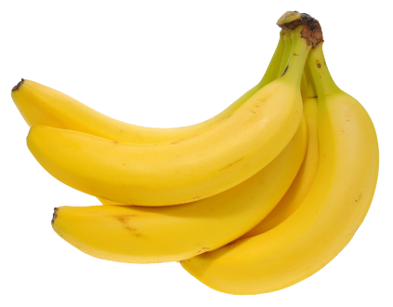
If you're like a lot of people, you buy a bunch of bananas, and before too many days go by, you end up with squishy, brown-spotted fruit which is only good for banana bread. Can you put bananas in the refrigerator to keep longer, say a week instead of a few days?
Yes. When bananas are refrigerated, they instantly stop ripening at the level of ripeness you put them in, giving you perhaps a week more stability. The skin, however, will turn brown and splotchy, which is not an indication of the fruit inside.
So, if you like the taste of green bananas, and you put green bananas in the refrigerator, four or five days later when you pull them out, you'll still have green bananas on the inside, even though the outside looks brown. You won't be able to ripen them further by putting them out on the counter. They'll simply go bad.

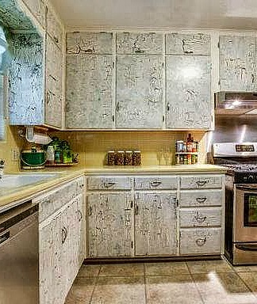
Bad DIY Projects Cost More When You Sell
With the popularity of Pinterest and DIY shows, it’s common for real estate agents to see homes with odd DIY projects. Many of these projects look unprofessional, idiosyncratic (appeals to just that homeowner) and even weird. Just because it seemed like a good idea to add crackle paint to your kitchen cabinets doesn’t mean everyone will agree. This kind of unusual feature can reduce the attractiveness—and selling price—of a home.
Buyers will often avoid making offers on homes with odd DIY projects, due to the time and money required to redo the projects, either through their own labor or by hiring a professional. So before you sell, get some impartial opinions about any DIY projects you’ve added. Then consider hiring a contractor to redo projects to ensure everything looks finished and “normal.”

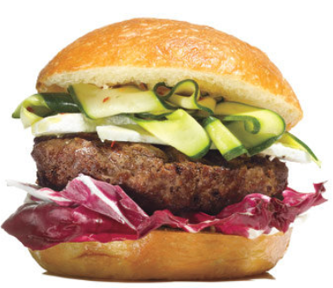
Quick & Easy Tips for Perfect Burgers
Want to know what's hard? Grilling hamburgers. According to Chef Barry Danieler, most people let the meat dry out or they over-spice it. For perfect grilled burgers, here are his six tips:
- Use fresh (not previously frozen) ground beef, 80-85% lean.
- Add a little red wine to make your beef taste more robust.
- Don't over-handle or compact the meat. Let it stay loose.
- After forming patties, press a divot into the middle with your thumb. This allows the juices to flow to the middle and keeps the meat moist. You can also press an ice cube into the divot after popping it onto the grill.
- Place patties onto an already hot grill. Cook 2 minutes per side for rare, 3 for medium-rare, 4 for medium, and 5 for well-done.

