# Extra Articles Instructions

Below are **three** extra articles. To use one of these extra articles in your newsletter:

**PRINT-FORMAT NEWSLETTERS**

1. Copy the text of an article below. Then paste it into an existing frame on your newsletter (highlight the existing text, then paste over it). **You may need to edit the content to fit the space after pasting it.**
2. Copy the image separately, then paste it into your newsletter and move it into place using your mouse. **You may need to edit the margins of your text to fit around your image.**

**EMAIL-FORMAT NEWSLETTERS**

If you plan to use one of these articles in the MailChimp newsletter, copy and paste the text into your email newsletter (using a new Text Box) and reformat as needed. You’ll have to save the image to your own computer and upload it to your MailChimp account if you wish to use the image with the article.

**INVESTOR ARTICLE**

This month, we have started adding an investor article as a 4th option, for those of you with investor clients. Scroll to the bottom to find this month’s investor article.

# What should I know before buying a condo?

Before buying a condo, get answers to these three big questions: **1. What is the HOA like? 2. What is the condition of the complex? 3. What is the renter-to-owner ratio.** The first question relates to quality of life in the complex. The second relates to continued financial benefit from buying a condo in that complex. The third tells you if there are a lot of caring owners vs. unvested renters living there.

We hear horror stories about restrictive HOA's (for instance, fining you for drying clothes on your balcony). To know how difficult the HOA is, talk to current residents if possible.

To determine if your condo is in good condition, look around the complex. Does it look like there is deferred maintenance? Does it seem like the grounds are well-maintained? Does it appear that the infrastructure will need a major renovation soon (such as new roofs or stairs)? These are not necessarily deal breakers. Find out if the HOA has a plan for renovations and if the money is already there, or if they plan to do an assessment that would raise your HOA fee. Most likely, there is a maintenance company in charge of managing such things, and they’ll have a phone number you can contact for information. Have your agent get a copy of the HOA's CC&R's (covenants and restrictions) and read it.

Finally, ask the HOA (or as your agent to ask) what percentage of renters vs. owners are in the complex. This is not only important for quality of life, but may affect financing, because many lenders have owner/renter limitations*.*

# Don’t Count On Catching Up On Sleep

You work long hours during the week, so you probably look forward to some extra sleep over the weekend. But if you’re counting on those couple of extra hours to help you catch up on all the rest you need, you may be fooling yourself.

In a study conducted at Penn State University, 30 healthy men and women aged 18-34 years spent 13 nights in a sleep lab. For four nights, they slept a full eight hours; then they spent six nights sleeping only six hours, followed by three 10-hour nights.

The participants’ brain function dropped after their nights of sleep deprivation and did not return to normal until after the third day of extra sleep, even though they said they felt physically refreshed by their extra sleep immediately.

So don’t depend on a few extra hours to bring you back to peak efficiency. Make a point of getting a full night’s sleep to stay safe and productive at home, work, and on the road.

# Not All Cooking Oils Are the Same

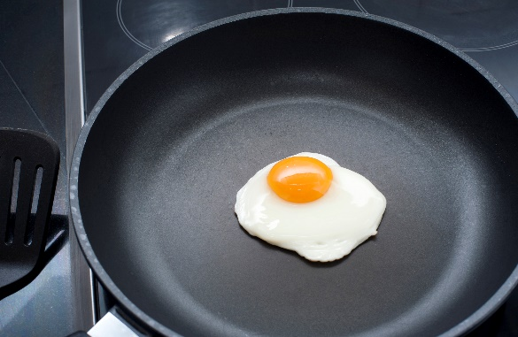All oils are 100% fat, meaning that they all have 9 calories per gram. Oils that claim to be "light" are making a statement about their flavor, not their calories. However, what's in those calories still makes some oils healthier than others.

Healthy oils include olive, sunflower, canola, grape seed, safflower, walnut, flaxseed and peanut.

Not all of these oils are good for frying, though. In fact, if you heat certain oils past a certain temperature, they can become unhealthy. For high-temperature cooking, such as deep frying, stick to canola, sunflower or peanut oil.