Extra Articles Instructions
Below are three extra articles. To use one of these extra articles in your newsletter:
PRINT-FORMAT NEWSLETTERS
- Copy the text of an article below. Then paste it into an existing frame on your newsletter (highlight the existing text, then paste over it). You may need to edit the content to fit the space after pasting it.
- Copy the image separately, then paste it into your newsletter and move it into place using your mouse. You may need to edit the margins of your text to fit around your image.
EMAIL-FORMAT NEWSLETTERS
If you plan to use one of these articles in the MailChimp newsletter, copy and paste the text into your email newsletter (using a new Text Box) and reformat as needed. You’ll have to save the image to your own computer and upload it to your MailChimp account if you wish to use the image with the article.

INVESTOR ARTICLE
This month, we have started adding an investor article as a 4th option, for those of you with investor clients. Scroll to the bottom to find this month’s investor article.

Life-Changing Passwords
Last month, you saw an article about creating memorable passwords. Now here’s a way to use passwords as a tool for making changes in your life.
Several years ago, a young man named Maruicio Estrella found himself in an angry depression due to a recent divorce. The final straw seemed to be one day when he walked into his office and was faced with a "Your Password Has Expired" message on his computer.
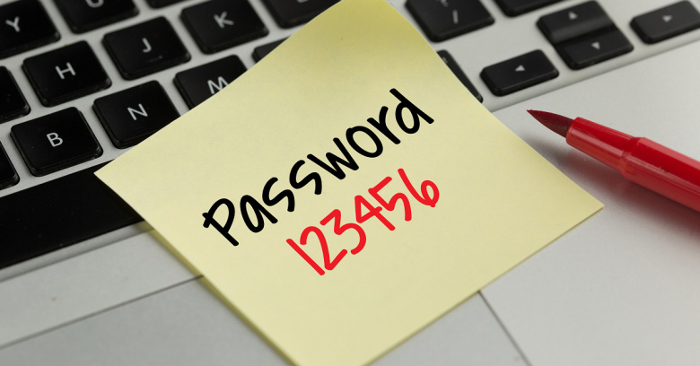As he was resetting it, he had a sudden insight. He came up with the password Forgive@h3r (forgive her). The constant reminder over the next 30 days as he typed in his password every morning seeped into his subconscious. It had a healing effect on him.
At the end of 30 days, he changed his password to Quit@smoking4ever. According to Estrella, he quit smoking overnight. Here are some other passwords he has used since, and his results:
- Save4trip@thailand. I went 3 months later.
- Sleep@before12. It worked. Got lots of sleep.
- No@drinking2months. It worked, felt great!
- Eat2times@day. Never worked, still fat.

“Should I buy property right after high school?”
My initial response to this unusual question was Are you crazy? But then I thought, Why not? Your youth can work to your advantage, especially when a smart parent stands with you. Here are some ways to look at investing in your first property at a young age:
1. You could plan to live in a property for a few years, wait for the value to rise, then sell it to fund your next purchase. For instance, you could buy near college and rent it out to roommates, then sell when you graduate.
2. If the cash flow is there, you can rent the property out to others while you do something else with your life. Be sure to include a management plan.
3. If it's a fixer, you can live in it, put in sweat equity, and then resell at a profit. Some loans will not allow you to sell within a certain time frame of when you buy, so consider that when looking at loans.
If you know a young person who wants to buy property, get in touch with me. Together we'll help them succeed.

Investor Article

Buying Small Commercial?

Think Resale before Buying
Among the many thing you should consider before buying a small suburban or urban commercial property is your exit plan. By identifying the type of future buyer for a property, you can focus on what features that buyer may want, then operate the property in a way that enhances those features. Examples:
- Apartment buildings could be purchased by pension funds and insurance companies, but only when they are Grade A properties. Syndicators look for Grade B or higher. Wealthy individuals are prospects for apartment buildings that need to be upgraded.
- Office buildings are typically purchased by users (a bank, insurance company, or corporation that plans to occupy the building for its own operations). Foreign investors often seek fully tenanted office buildings for long-term investment.
- Resort properties (time-share, beach condos, campgrounds) generally have a weak resale market. Sale by auction is a possibility and that often results in bottom-dollar prices.
Before selling, make effort to ensure the financial and physical condition of the property justify the maximum possible price. In a shopping center, for example, the rental income stream, cash flow, and occupancy level should each be at the highest possible level. When they are, you'll have a greater number of potential buyers. Also consider like-kind exchange possibilities, rather than straight resale.

